29.9: a) 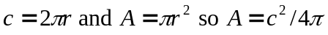
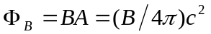
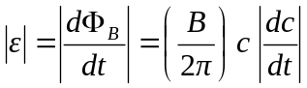
At
b)
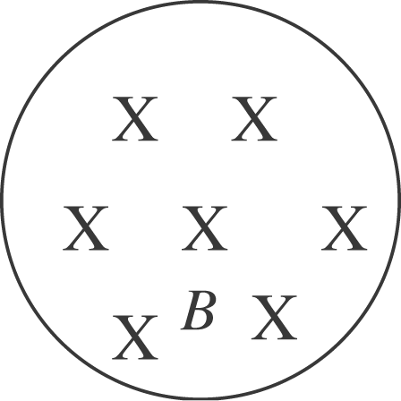 Fluxis decreasing so the flux of the induced current
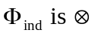 and I is clockwise.

